2. Trate Stransition Diagram
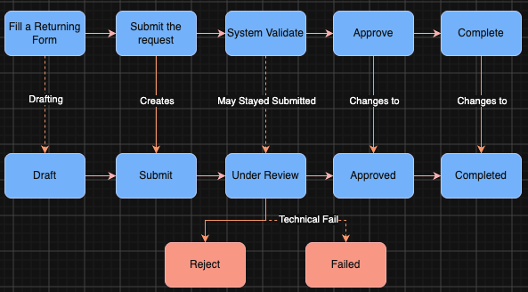
3. State Definition
Draft: The customer has started the return form but has not sent it yet. The information can still be edited.
Submitted: The return request has been sent, and a request record now exists in the system. It is waiting to be checked under business rules and system rules.
Under Review: The system is validating the request to see whether the form qualified for next state or having problems with business rule (Reject) or the technical error (Failed).
Approved: The request passed validation and review, and the return is authorized.
Completed: The process of submitting return request is finished. This is a final state.
Rejected: The request was reviewed and denied due to violating business rules. This state ends the process
Failed: The request stopped because of a technical problem, not because of a decision. This state ends the process.

